**SOLUTION DESIGN DOCUMENT**

Version 1.0

**CROWN Order Cancellation**

Revision History

Version History

|  |  |  |  |
| --- | --- | --- | --- |
| Date | Revision | Author | Description |
| 22-05-2024 | 1.0 | Clifton Lenne | Draft Version |
|  |  |  |  |

Validation

|  |  |  |  |
| --- | --- | --- | --- |
| Date | Revision | Name | Approval |
|  |  |  |  |
|  |  |  |  |
|  |  |  |  |

Contents

Revision History 1

Version History 1

Validation 1

Distribution 3

Introduction 4

Overview 4

Solution Architecture 4

Solution Overview 4

Solution Design Workflow 5

Solution Components 5

Data Model 12

Physical Data Model in Microsoft Dataverse 12

Semantic Data Model in Microsoft Power BI / Microsoft Fabric 12

Data Import Process for Microsoft Dataverse 13

Automation Schema 14

Power Platform Dataflows 14

Standard Queries for CNL_0330 and CNL_0313 14

Data Import CNL_0330 16

Data Import CNL_0313 17

Data Import AX_View 19

Conditional Data Import (Optional) 20

Data Archival, Retention and Lifecycle 20

Security in Microsoft Dataverse 21

Security Roles and Security Groups 21

[Placeholder Power BI section] 22

Environmental Setup 22

Accounts and Environments 22

Environmental Variables 23

License Requirements 23

Service account 23

Business Users 24

Risk (R) and Dependencies (D) 24

# Distribution

The information has restricted distribution and viewing within Chanel.

Document Sign-off Requirements

The following table contains the people required to sign-off and/or review this document and those that require the document for information only.

|  |  |  |
| --- | --- | --- |
| Name | Department | Responsibility |
|  |  |  |
|  |  |  |

# Introduction

## Overview

The Objective of this solution is to enable APAC Business User to view and follow-up Calculated Order Summary data and Cancellation Inquiry data. The solution shall:

* Check for uploaded CSV files.
* Send notifications.
* Extract the data from the CSV files and save it into Dataverse tables.
* Extract data from the AX SQL database and save it into Dataverse tables.

# Solution Architecture

## Solution Overview

The **CROWN Order Cancellation** Solution comprises a Power BI Report. This report will read data stored in Dataverse tables. These Dataverse tables are populated from CSV files stored on Microsoft SharePoint, and data retrieved from the AX SQL Database:

* **Azure Blob/Alternative Storage**: CSV Files are made available through Azure Blob Storage or an alternative storage location (by Apollo).
* **SharePoint**: CSV Files are copied to SharePoint Library, for processing and to comply to archival and retention requirements as outlined in the BRD.
* **SQL Server**: AX data is fetched by calling a Stored Procedure, transforming the data and storing this data in Dataverse tables.

To ensure an optimal performance of the app, thus minimizing the size of the data to be processed, only the relevant data fields are utilized.

## Solution Design Workflow

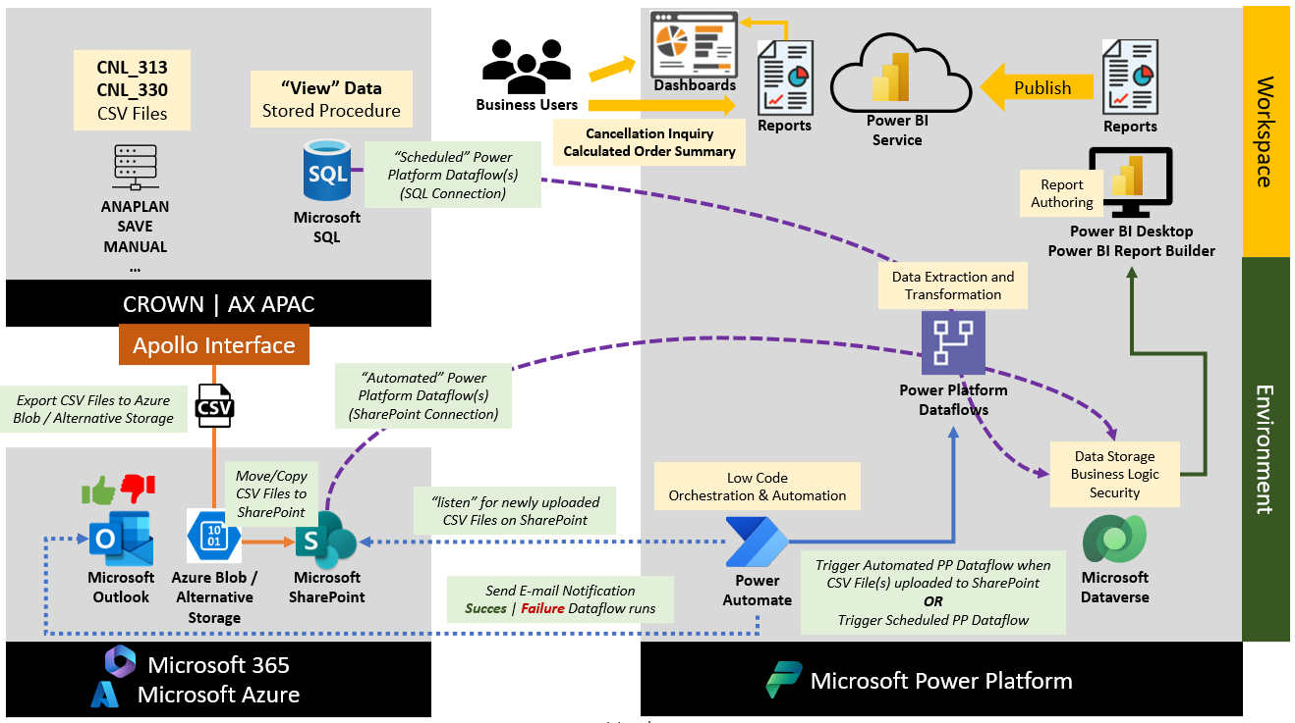

Figure 1 Solution Design Workflow CROWN Order Cancellation

## Solution Components

This Power Platform Solution makes us of the following Ecosystem**[1]** components:

|  |  |  |
| --- | --- | --- |
| **Component** | **Description** | **Value** |
| Azure Blob / Alternative Storage | Apollo drop-off location for CSV Files | * TBD |
| Microsoft SharePoint | Drop-off location CSV Files | * SharePoint Site: https://lpl.sharepoint.com/sites/CROWNOrderCancellation/ * SharePoint Library: CNL_AX_DATA_[*DEV/TST/PRD*] * SharePoint Library Folders:   + AX_View   + CNL_0313   + CNL_0330 |
| Power BI | Reports and Dashboards | * Interactive Reports   + Cancellation Inquiry Report   + Calculated order summary Inquiry Report * Workspace   + M_APAC_Hyperautomation_WS_[*DEV|UAT|PROD*] |
| Microsoft Dataverse | Storage of extracted and transformed data | * Table 1: Order Header * Alternate Key: Key_PURCHID_CUSTORDREF * Table 2: Order Line * Alternate Key: Key_BARCODE_PURCHID * Table 3: Order Header Staging (Optional) * Alternate Key: None * Table 4: Order Line Staging (Optional) * Alternate Key: None * Table 5: Cancelled Order Line * Alternate Key: None * Table 6: File Import Queue * Alternate Key: None |
| Power Platform On-Premises Data Gateway | Integrates Power Platform Services with On-Premises Sources | * DGW_Hyperautomation_APAC |
| Power Automate | Low Code orchestration of ETL processes, and management of notifications | * Cloud Flow 1: Initiate CNL_330_0313 Dataflow | Automated * Cloud Flow 2: Initiate AX View Dataflow | Scheduled * Cloud Flow 3: Send Custom Email Notification | Instant * Cloud Flow 4: Calculate Effective Cancelled Qty | Instant * Cloud Flow 5: Conditionally Update Order Lines (Optional) |
| Power Platform Data Connectors | Connectors used by the Main application and the corresponding (data)flows. | * Connector 1: File System * Connector 2: Microsoft Azure Blob Storage * Connector 2: Microsoft Dataverse * Connector 3: Office 365 Outlook * Connector 4: Microsoft SharePoint * Connector 5: Microsoft SQL * Connector 6: HTTP with Microsoft Entra ID (preauthorized) * Connector 7: Power Query Dataflows   **Connector References**:   * Dataverse_COCS_ConRef * Office365Outlook_COCS_ConRef * SharePoint_COCS_ConRef * HTTPMSEntraIDPreAuth_COCS_ConRef * PowerQuery_COCS_ConRef * TBD: MicrosoftSQL_COCS_ConRef * TBD: FileSystem_COCS_ConRef * TBD: AzureBlobStorage_COCS_ConRef |
| Power Platform Dataflow | Extract and Transform CNL and AX data and import in Microsoft Dataverse table(s) utilizing Power Query | **Headers and Line Items for CNL_0330, CNL0313 and AX View**   * DF_Orders_[*Name*]_CROWN_ORDER_CANCELLATION |

The following steps will be performed in the process.

***Copy/Move CSV Files from Azure Blob/Alternative Storage to SharePoint***

* + The Apollo Team places CSV files on Azure Blob/Alternative Storage.
  + These CSV files are than picked up and placed on SharePoint by an Automated (Option 1) or Scheduled (Option 2) Power Automate Cloud Flow.

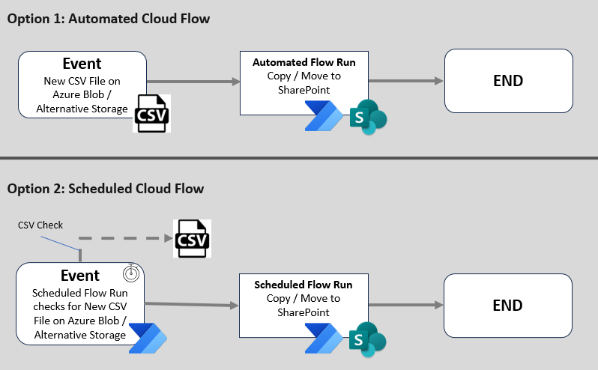

Figure 2 Copy/Move CSV Files from Azure Blob / Alternative Storage to SharePoint

***Retrieve CSV Files from SharePoint***

* + An Automated Power Automate Flow runs an instant Power platform Dataflow whenever a new CSV file is placed on SharePoint.
  + Data Transformation and Import has 2 scenarios:
    - **Regular Route**. Source Data can be imported as the required validations and/or transformations are fully supported by the Power Platform Dataflow. In this case data is copied directly to the destination Dataverse table(s) by the Power Platform Dataflow.
    - **Intermediate Route.** Source Data requires additional validation and/or transformations, not (fully) supported by the Power Platform Dataflow. When this is the case, the data is first copied to an intermediate staging table in Dataverse. After which a mechanism (e.g. Plugin/Cloud Flow/Other) executes the additional steps, and finally moves the data to the target Dataverse table(s).
  + After each run a Cloud Flow sends a custom Success or Failure e-mail notification to the recipient(s).

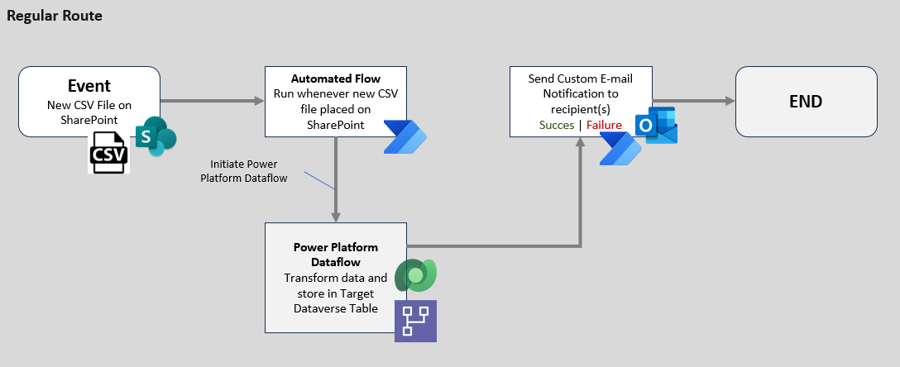

Figure 3 CSV Data Transformation and Import: Regular Route

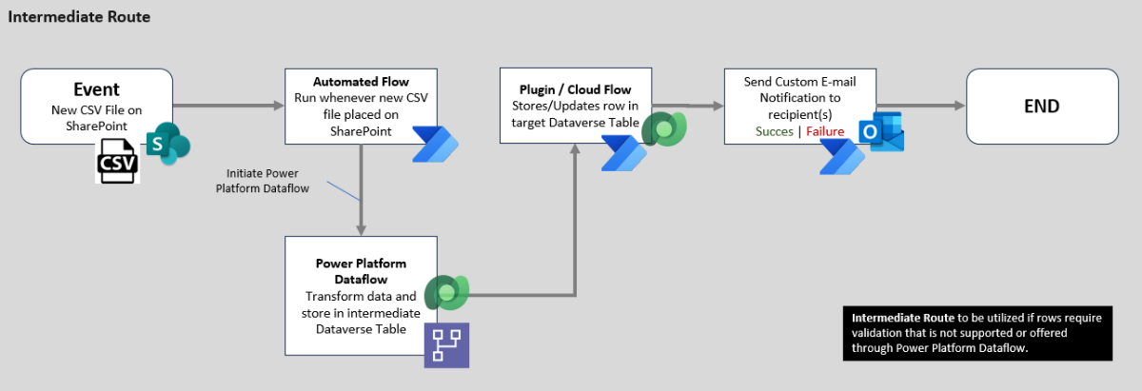

Figure 4 CSV Data Transformation and Import: Intermediate Route

***Retrieve AX Data***

* + A scheduled Power Platform Dataflow runs a Stored SQL Procedure on the AX SQL Database, retrieving the relevant data. Sequentially this data is transformed and stored in Dataverse. After each run a custom Success or Failure-mail notification is send to the target Stakeholder(s). Like the CSV files, AX data can optionally be stored on an Intermediate Table for further processing.

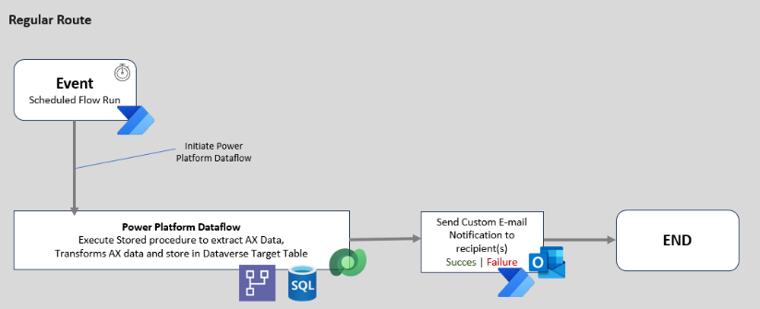

Figure 5 AX Data Transformation and Import: Regular Route

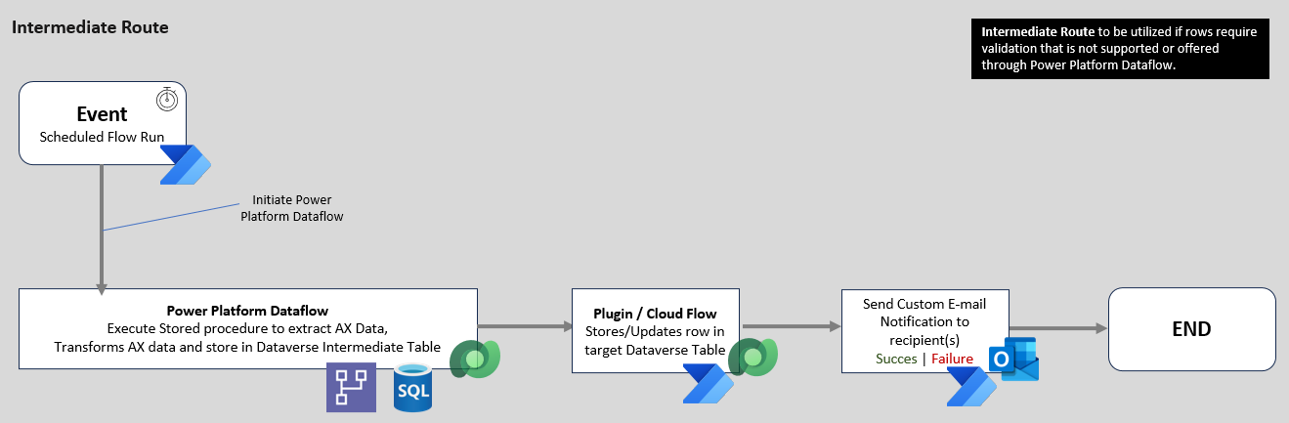

Figure 6 AX Data Transformation and Import: Intermediate Route

***Retrieve and Refresh Report Data***

* + Data which has been imported in Microsoft Dataverse, should be reflected inside Power BI. Therefore, the Power BI Semantic Model (see next section) is refreshed 4 times per day:
    - 08:00 AM
    - 12:00 PM
    - 16:00 PM
    - 20:00 PM

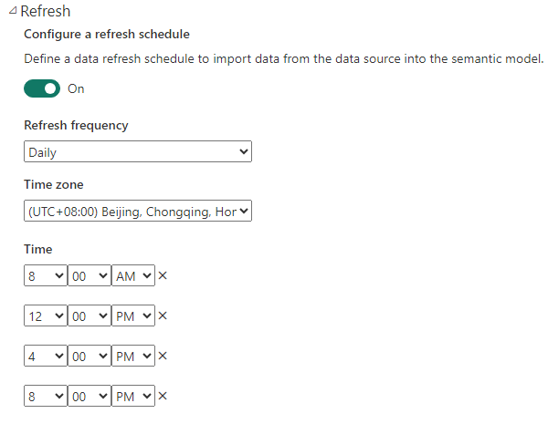

Figure 7 Semantic Model Refresh Schedule in Power BI

Optionally a Power Automate Cloud Flow can be configured to refresh the semantic model as part of an automated process:

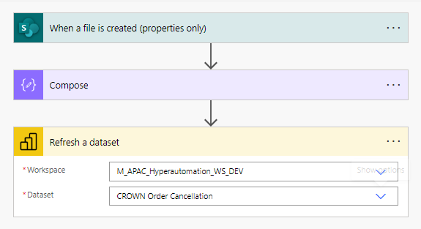

Figure 8 Example: Power BI Semantic Model Refresh via Power Automate

**Note regarding scheduling of Power Platform Dataflows**

To configure a scheduled Power Platform Dataflow two options are available:

* **Option 1**: Through built-in **Refresh Settings**

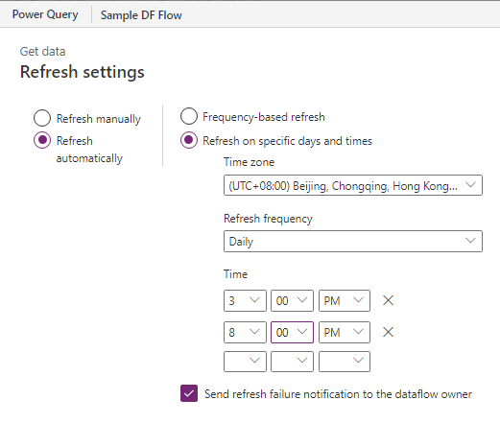

* **Option 2**: Through a **Scheduled Power Automate Cloud Flow**

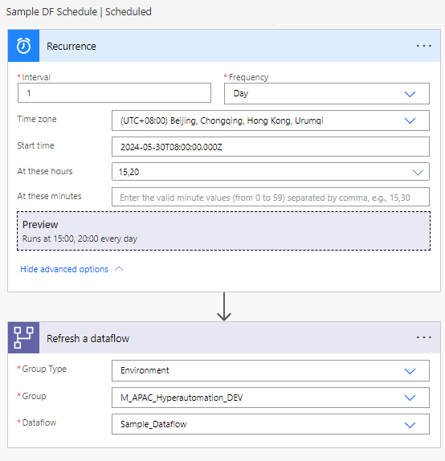

For the CROWN Order Solution **option 2** is utilized due to several reasons:

* By utilizing the Cloud Flow, the result (output) of the Power Platform Dataflow action (Refresh Status, Start Time, End Time, DF Name, DF ID, …) can be used as input in subsequent Cloud Flow actions, such as retrieving detailed Run History and using that information in custom e-mail notifications.
* Secondly, the built-in Refresh Settings do not support the following:
  + Adding additional recipients. By default, only the owner of the dataflow (ref. General HA account) receives e-mail notifications.
  + Customizing the e-mail notification’s content and layout. By utilizing the Outlook Connector, Business-aligned email notifications can be compiled.

# Data Model

## Physical Data Model in Microsoft Dataverse

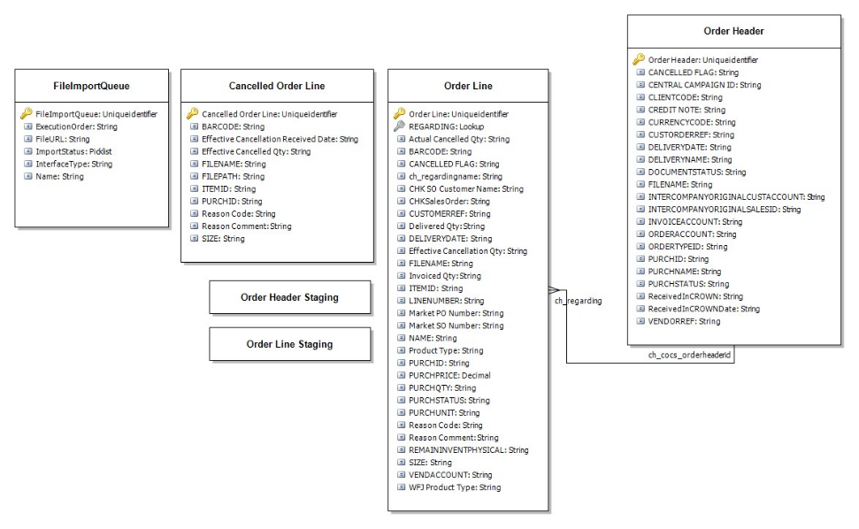

Figure 9 Physical Data Model in Microsoft Dataverse

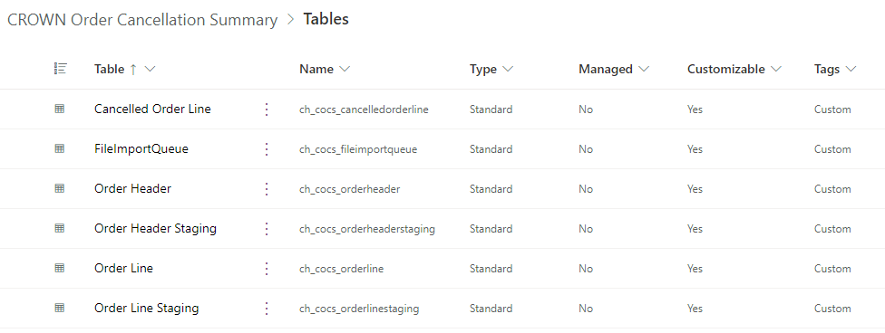

Figure 10 Physical tables in Microsoft Dataverse

## Semantic Data Model in Microsoft Power BI / Microsoft Fabric

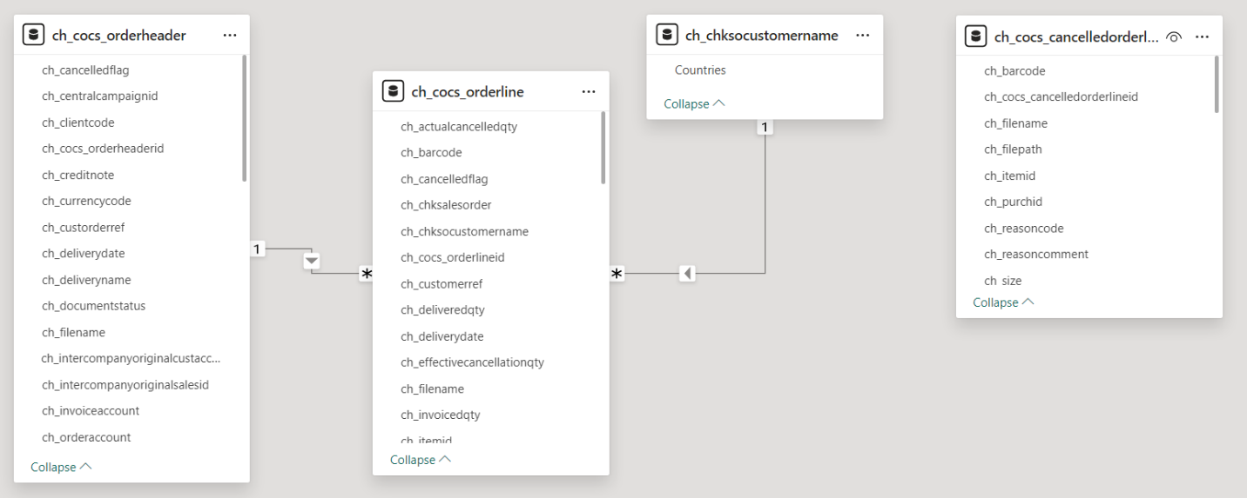

Table 2 Semantic Model in Power BI (Draft 20 May 2024)

# Data Import Process for Microsoft Dataverse

Headers and Lines should be imported in a specific order, resulting in a Create or Update. To ensure correct processing of these files, Import Jobs are stored in a **File Import Queue** table, and are orchestrated through an automated **Queue Orchestration** Power Automate Cloud Flow.

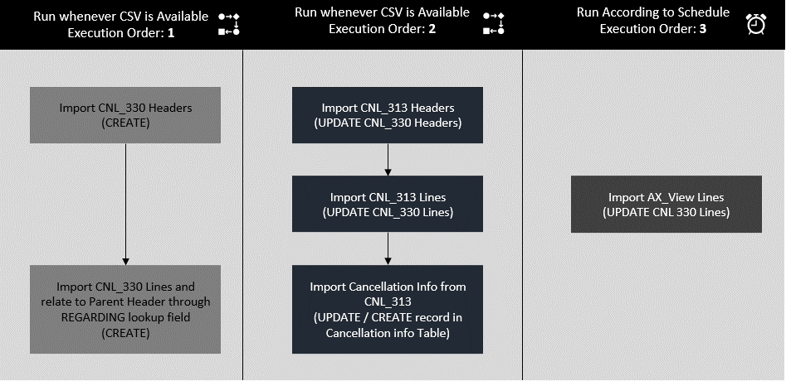

Figure 11 Import Order of Headers and Lines

## Automation Schema

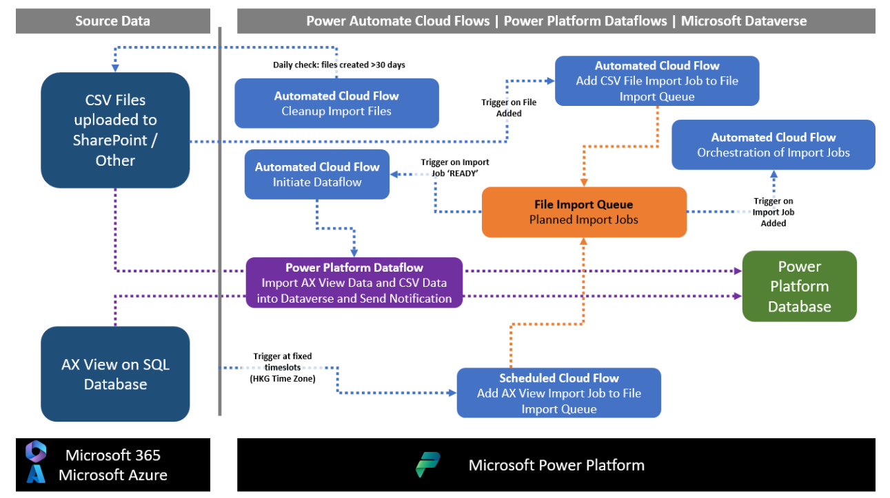

Figure 12 Automation Schema: Data Import

|  |  |  |
| --- | --- | --- |
| **Nr** | **Power Automate Cloud Flows managing Data Imports** | **Schema** |
| **1** | Add AX View Data Import Job to File Import Queue | Scheduled | [LINK](https://lpl.sharepoint.com/sites/APACHyperautomation/Shared%20Documents/Forms/AllItems.aspx?id=%2Fsites%2FAPACHyperautomation%2FShared%20Documents%2FCROWN%20Order%20Cancellation%20Summary%2FSchemas%5FDiagrams&viewid=f8577294%2Dddef%2D4b91%2D8726%2D79448bcd2156) |
| **2** | Add CSV Data Import Job to File Import Queue | Automated | [LINK](https://lpl.sharepoint.com/sites/APACHyperautomation/Shared%20Documents/Forms/AllItems.aspx?id=%2Fsites%2FAPACHyperautomation%2FShared%20Documents%2FCROWN%20Order%20Cancellation%20Summary%2FSchemas%5FDiagrams&viewid=f8577294%2Dddef%2D4b91%2D8726%2D79448bcd2156) |
| **3** | Cleanup Import Files | Scheduled | [LINK](https://lpl.sharepoint.com/sites/APACHyperautomation/Shared%20Documents/Forms/AllItems.aspx?id=%2Fsites%2FAPACHyperautomation%2FShared%20Documents%2FCROWN%20Order%20Cancellation%20Summary%2FSchemas%5FDiagrams&viewid=f8577294%2Dddef%2D4b91%2D8726%2D79448bcd2156) |
| **4** | Initiate Dataflow | Parent | Automated | [LINK](https://lpl.sharepoint.com/sites/APACHyperautomation/Shared%20Documents/Forms/AllItems.aspx?id=%2Fsites%2FAPACHyperautomation%2FShared%20Documents%2FCROWN%20Order%20Cancellation%20Summary%2FSchemas%5FDiagrams&viewid=f8577294%2Dddef%2D4b91%2D8726%2D79448bcd2156) |
| **5** | Queue Orchestration | Automated | [LINK](https://lpl.sharepoint.com/sites/APACHyperautomation/Shared%20Documents/Forms/AllItems.aspx?id=%2Fsites%2FAPACHyperautomation%2FShared%20Documents%2FCROWN%20Order%20Cancellation%20Summary%2FSchemas%5FDiagrams&viewid=f8577294%2Dddef%2D4b91%2D8726%2D79448bcd2156) |
| **6** | Refresh Dataflow and Send Notification | Child | Instant | [LINK](https://lpl.sharepoint.com/sites/APACHyperautomation/Shared%20Documents/Forms/AllItems.aspx?id=%2Fsites%2FAPACHyperautomation%2FShared%20Documents%2FCROWN%20Order%20Cancellation%20Summary%2FSchemas%5FDiagrams&viewid=f8577294%2Dddef%2D4b91%2D8726%2D79448bcd2156) |

## Power Platform Dataflows

### Standard Queries for CNL_0330 and CNL_0313

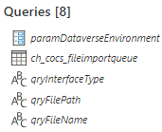

Above queries are included in the Dataflows for CNL_0330 and CNL_0313

|  |  |
| --- | --- |
| Query Label | Query |
| paramDataverseEnvironment: Target Power Platform Environment  *Environment URL:*  *DEV: orgb65cd65f.crm4.dynamics.com*  *UAT: hyperautomation-uat.crm4.dynamics.com*  *PROD: org03fd7e3f.crm4.dynamics.com* | |
|  | |
| ch_cocs_fileimportqueue: Queue to determine next file to import.  *InterfaceType: CNL_0330 OR CNL_0313 OR AX_View* | |
|  | |
| qryInterfaceType: Show Interface Type to store in Dataverse | |
|  | |
| qryFilePath: Show File Path to import data from File in Dataverse and to use in consecutive reporting | |
|  | |
| qryFileName: Show File Path to import data from File in Dataverse and to use in consecutive reporting | |
|  | |

### Data Import CNL_0330

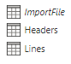

* Import Mechanism: **Power Platform Dataflow**
  + Frequency: Whenever File is available on Storage
  + Dataflow: **DF_Orders_CNL_0330_CROWN_ORDER_CANCELLATION**
  + Destination: Order Header and Order Line

|  |  |
| --- | --- |
| Query Label | Query |
| ImportFile: Determine File to Import | |
|  | |
| Order Headers: Split Out Headers | |
|  | |
| Order Lines: Split Out Lines | |
|  | |

### Data Import CNL_0313

* Import Mechanism: **Power Platform Dataflow**
  + Frequency: Whenever File is available on Storage
  + Dataflow: **DF_Orders_CNL_0313_CROWN_ORDER_CANCELLATION**
  + Destination: Order Header and Order Line

|  |  |
| --- | --- |
| Query Label | Query |
| ImportFile: Determine File to Import | |
|  | |
| Order Headers: Split Out Headers | |
|  | |
| Order Lines: Split Out Lines | |
|  | |
| Cancelled Order Lines: Split Out Cancelled Lines | |
|  | |

### Data Import AX_View

* Import Mechanism: **Power Platform Dataflow**
  + Frequency:
    - Scheduled
    - Twice a day
      * Sync 1: 15:00 Hong Kong Timezone
      * Sync 2: 20:00 Hong Kong Timezone
  + Dataflow: **DF_Orders_AX_View_CROWN_ORDER_CANCELLATION**
  + Destination: Order Line

|  |  |
| --- | --- |
| Query Label | Query |
| ImportFile: Determine File to Import [To be updated with SQL Stored Procedure once available] | |
|  | |

### Conditional Data Import (Optional)

In some scenario’s data cannot be directly imported as of reasons stated earlier. In that case a Power Automate Cloud Flow is being used to copy data from and intermediate Dataverse table to the destination/target table.

For this scenario two Intermediate Tables have been created:

* Order Header Staging
* Order Lines Staging

Via this [**link**](https://lpl.sharepoint.com/sites/APACHyperautomation/Shared%20Documents/Forms/AllItems.aspx?id=%2Fsites%2FAPACHyperautomation%2FShared%20Documents%2FCROWN%20Order%20Cancellation%20Summary%2FSchemas%5FDiagrams&viewid=f8577294%2Dddef%2D4b91%2D8726%2D79448bcd2156) an example where we copy AX_View records from the **Order Line Staging** table to the **Order Line Table**:

* Import Mechanism: **Power Automate Cloud Flow**
  + Frequency: Whenever New Record is Added to Staging Table
  + Cloud Flow: **Conditionally Update Order Lines | Automated**
  + Target Destination: Order Line

## Data Archival, Retention and Lifecycle

BRD requirement: ***If all the order lines pertaining to a purchase order has been invoiced for 3 months, then archive those order data.***

**For this the Long Term Retention flag is enabled on the applicable tables:**

* **Order Header**
* **Order Lines**
* **Cancelled Lines**

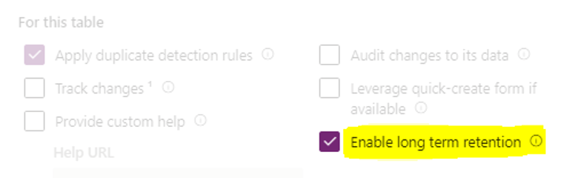

Figure 13 Long Term Retention

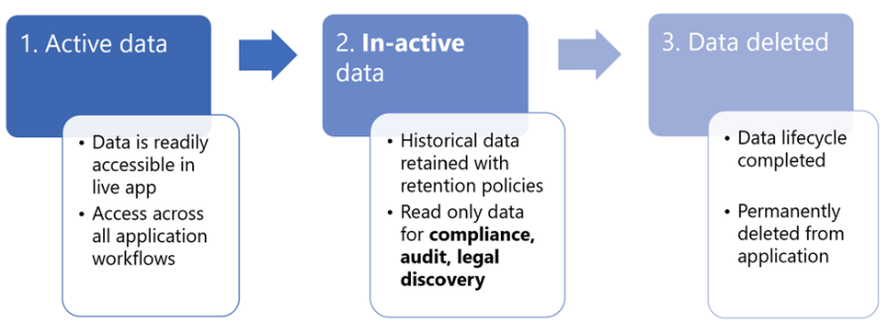

Figure 14 Data Archival and Retention: Lifecycle

**Important**: Once data is retained with Dataverse long term retention it can't be moved back to the Dataverse live (active) application state.

**Retention Policy Criteria** [To be filled out once criteria are known]

Answer Sajan:

Hi Clifton, we would need to discuss this in detail during solution design document.

But at a high level what I can think of is as follows:

If for all orderline pertaining to purch if the remain invent physical = 0 and the last view update recieved for this PO was >3 months then it can be archived. The rule needs to be signed off from business though this is what I can think off

# Security in Microsoft Dataverse

## Security Roles and Security Groups

Users are assigned several Security Roles, granting them access to underlying Dataverse tables.

|  |  |
| --- | --- |
| **Defined Security Roles** | **Description** |
| App Opener | Allow Users to Launch Apps |
| Basic User | Allows user to perform Basic Read-Write Operations |
| CROWN Order Cancellation – Admins | Grants Read access to all reporting tables |
| CROWN Order Cancellation - Cancellation Inquiry Report Viewer | Grants Read access to Effective Cancellation Table and associated Order Headers and Order Lines |
| CROWN Order Cancellation - Calculated Order Summary Report Viewer | Grants Read access to Order Header and Order Line Tables |

Security Roles are **not** assigned directly. Instead, they are assigned via **Dataverse Team Groups**. These Dataverse Team Group are linked to **Microsoft Entra ID Security Groups**. **Group Owners** can manage **Group Membership**, determining who has or gets access to the data in the Dataverse tables.

|  |  |
| --- | --- |
| **Dataverse Team Group** | **Assigned Role** |
| TEAM-CROWNOrderCancellation–Admins | * App Opener * Basic User * CROWN Order Cancellation – Admins |
| TEAM-CROWNOrderCancellation-Cancellation Inquiry Report Viewer | * App Opener * Basic User * CROWN Order Cancellation - Cancellation Inquiry Report Viewer |
| TEAM-CROWNOrderCancellation-Calculated Order Summary Report Viewer | * App Opener * Basic User * CROWN Order Cancellation - Calculated Order Summary Report Viewer |

Dataverse Team Groups are linked to the following Microsoft Entra ID Security Groups:

|  |  |
| --- | --- |
| **Dataverse Team Group** | **Microsoft Entra ID Security Group** |
| TEAM-CROWNOrderCancellation–Admins | TBD |
| TEAM-CROWNOrderCancellation-Cancellation Inquiry Report Viewer | TBD |
| TEAM-CROWNOrderCancellation-Calculated Order Summary Report Viewer | TBD |

## Security Schema for Microsoft Dataverse

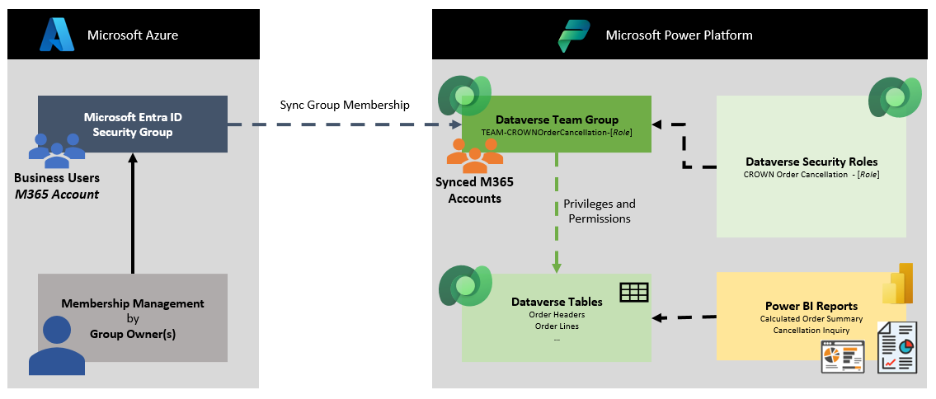

Figure 15 Microsoft Dataverse Security Schema

# Data Import Process for Power BI

In Power BI the Following queries are executed:

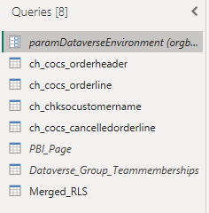

|  |  |
| --- | --- |
| Query Label | Query |
| paramDataverseEnvironment: Power Platform Source Environment | |
|  | |
| ch_cocs_orderheader: Order Header Source Table | |
|  | |
| ch_cocs_orderline: Order Line Source Table | |
|  | |
| ch_chksocustomorname: Countrylist (Power BI Virtual Table) | |
|  | |
| ch_cocs_cancelledorderline: Cancelled Order Lines Source Table [To be updated w/ additional logic] | |
|  | |
|  | |

To enforce Report Security, in that sense that users only see the reports based on their Group Membership, the following 3 queries are used:

|  |  |
| --- | --- |
| Query Label | Query |
| PBI_Page: Lists the name of the Report Page an the Dataveres eTeam groups that have access. | |
|  | |
| Dataverse_Group_Teammembership: Lists the membership of the CROWN Dataverse Team Groups | |
|  | |
| Merged_RLS: Merger of previous 2 queries, offering a listing of the users who have access to the different Reports and/or Report Sections. | |
|  | |
|  | |

# [Power BI User Experience Placeholder]

[Placeholder Mockups]

# Environmental Setup

## Accounts and Environments

|  |  |  |  |
| --- | --- | --- | --- |
| Service Account | ga-ha_lowcode@chanel.com | | |
| Power Platform Environment | M_APAC_Hyperautomation_[*DEV | UAT | PROD*] | | |
| AX Server | **DEV** | **TST** | **PRD** |
| *SQL Server* | HKDATAPAXU02 | HKDATAPAXU02 | TBD |
| *Database* | HKDATAXSQLU2 | HKDATAXSQLU2 | TBD |
| *Stored Procedure* | CNLAS_GetPurchLineData | |  |
| Power BI Environment  *General HA Account has full access* | * **DEV:** M_APAC_Hyperautomation_WS_DEV * **UAT:** M_APAC_Hyperautomation_WS_UAT * **PRD:** M_APAC_Hyperautomation_WS_PROD | | |

## Environmental Variables

|  |  |
| --- | --- |
| Environment Variable | Description | Value |
| **SP Site | CROWN Cancellation | Env. Variable**  *SharePoint Site for storage of CROWN *.CSV files.* | **DEV (Default):** https://lpl.sharepoint.com/sites/CROWNOrderCancellation/  **UAT (Current):** N/A  **PRD (Current):** N/A |
| **SP Site Root URL | CROWN Cancellation | Env. Variable**  *SharePoint URL Path for storage of CROWN *.CSV files.* | **DEV (Default):** https://lpl.sharepoint.com/sites/CROWNOrderCancellation/  **UAT (Current):** N/A  **PRD (Current):** N/A |
| **SP Library | CROWN Cancellation | Env. Variable**  *SharePoint Library for storage of CROWN *.CSV files.*  *Folder Names: CNL_0330, CNL_0313, AX_View*  ***Do not move or rename these folders, as Automation logic is depended on it.*** | **DEV (Default):** CNL_AX_DATA_DEV  **UAT (Current):** CNL_AX_DATA_TST  **PRD (Current):** CNL_AX_DATA_PRD |
| **DF_WSGRP_ID | CROWN Cancellation | Env. Variable**  *ID of the Power Platform Dataflow Environment* | **DEV (Default):** 65a5faeb-0e16-e739-8d60-dbc994445b53-31c688f59-europe  **UAT (Current):** TBD  **PRD (Current):** TBD |
| **DF_ID_CNL_330 | CROWN Cancellation | Env. Variable**  *Power Platform Dataflow ID for CNL_330* | **DEV (Default):** e581be67-79c7-4cf5-88b4-e17f87b73737  **UAT (Current):** TBD  **PRD (Current):** TBD |
| **DF_ID_CNL_313 | CROWN Cancellation | Env. Variable**  *Power Platform Dataflow ID for CNL_313* | **DEV (Default):** c3b28f3f-76b2-465a-8ac9-53cca49772c2  **UAT (Current):** TBD  **PRD (Current):** TBD |
| **DF_ID_AX_View | CROWN Cancellation | Env. Variable**  *Power Platform Dataflow ID for AX_View* | **DEV (Default):** 414987b7-f798-4030-b805-a0fe6c37ea39  **UAT (Current):** TBD  **PRD (Current):** TBD |

## License Requirements

### Service account

The Generic Developer Account will be utilized. This account should have the following licenses assigned:

* Power Apps Premium
* Power Automate Premium
* Power BI Pro (included in Microsoft 365 License)
* Microsoft 365 E5 (formerly Office 365 E5)

By utilizing this account, the Developer(s) will be able to build the necessary Solution components without any limitations.

### Business Users

Power BI Reports/Dashboard

Business Users will need at least a Power BI Pro license to be able to view the Power BI Reports and Dashboard.

# Risk (R) and Dependencies (D)

* (D) Delivery of CSV files by Apollo Team through suitable medium (Azure Blob / SharePoint / Alternative Storage)
* (D) AX View Stored Procedure by AX Team
* (D) Hyperautomation Team’s access to AX file share via Power Platform On-Premises Data Gateway (Optional)

1. Power Platform Ecosystem consists of (1) Native Power Platform capabilities, (2) Microsoft 365, (3) Microsoft Azure, (4) Microsoft Dynamics 365, (5) Third Party Applications, (6) Pro Code Components